# Team members report by 20/04/2017

## Table view

|  |  |
| --- | --- |
| Name | Role |
| Eric | Program Manager |
| Bob | Developer |
| Total | 2 members |

## List view

1. Eric, Program Manager
2. Bob, Developer

## Nested list view

1. Program Manager
   1. Eric
   2. Ann
2. Developer
   1. Bob
   2. Richard

## List inside table

|  |  |  |
| --- | --- | --- |
| Name | Role | Projects |
| Eric | Program Manager | 1. Project one 2. Project two |
| Bob | Developer | 1. Project one 2. Project three |

## Table inside list

1. Project one

|  |  |
| --- | --- |
| Name | Role |
| Eric | Program Manager |
| Bob | Developer |

1. Project two

|  |  |
| --- | --- |
| Name | Role |
| Eric | Program Manager |

1. Project three

|  |  |
| --- | --- |
| Name | Role |
| Bob | Developer |

## Several blocks

|  |  |
| --- | --- |
| Name | Eric |
| Role | Program Manager |
| Name | Richard |
| Role | Program Manager |
| Name | Bob |
| Role | Developer |
| Statistics | |
| Program Manager | 2 |
| Developer | 1 |

## Merged rows

|  |  |  |  |
| --- | --- | --- | --- |
| Name | Eric | Role | Program Manager |
| Age | 37 |
| Gender | Male |
| Name | Bob | Role | Developer |
| Age | 33 |
| Gender | Male |
| Name | Ann | Role | Developer |
| Age | 34 |
| Gender | Female |

## Merged columns

|  |  |  |
| --- | --- | --- |
| Name | Role | Age |
| Eric | Program Manager | 37 |
| Projects | Project one, Project two | |
| Bob | Developer | 33 |
| Projects | Project one | |
| Ann | Developer | 34 |
| Projects | Project two | |

## Image

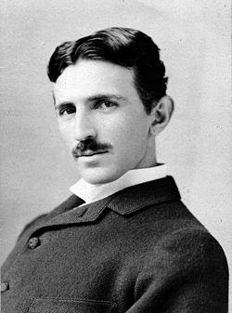

## Images inside a table

|  |  |  |  |
| --- | --- | --- | --- |
|  | Nicola Tesla | Born | 10/07/1856 |
| Info | Serbian American inventor, electrical engineer, mechanical engineer, physicist, and futurist best known for his contributions to the design of the modern alternating current (AC) electricity supply system |
|  | Thomas Edison | Born | 11/02/1847 |
| Info | American inventor and businessman. He developed many devices that greatly influenced life around the world, including the phonograph, the motion picture camera, and the long-lasting, practical electric light bulb. |
|  | Albert Einstein | Born | 14/03/1879 |
| Info | German-born theoretical physicist. He developed the general theory of relativity, one of the two pillars of modern physics (alongside quantum mechanics). Einstein's work is also known for its influence on the philosophy of science. Einstein is best known in popular culture for his mass–energy equivalence formula E = mc2 (which has been dubbed 'the world's most famous equation'). |

## Images inside a list

*  Nicola Tesla (1856-1943)
* Serbian American inventor, electrical engineer, mechanical engineer, physicist, and futurist best known for his contributions to the design of the modern alternating current (AC) electricity supply system
* 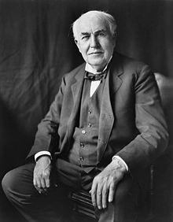 Thomas Edison (1847-1931)
* American inventor and businessman. He developed many devices that greatly influenced life around the world, including the phonograph, the motion picture camera, and the long-lasting, practical electric light bulb.
* 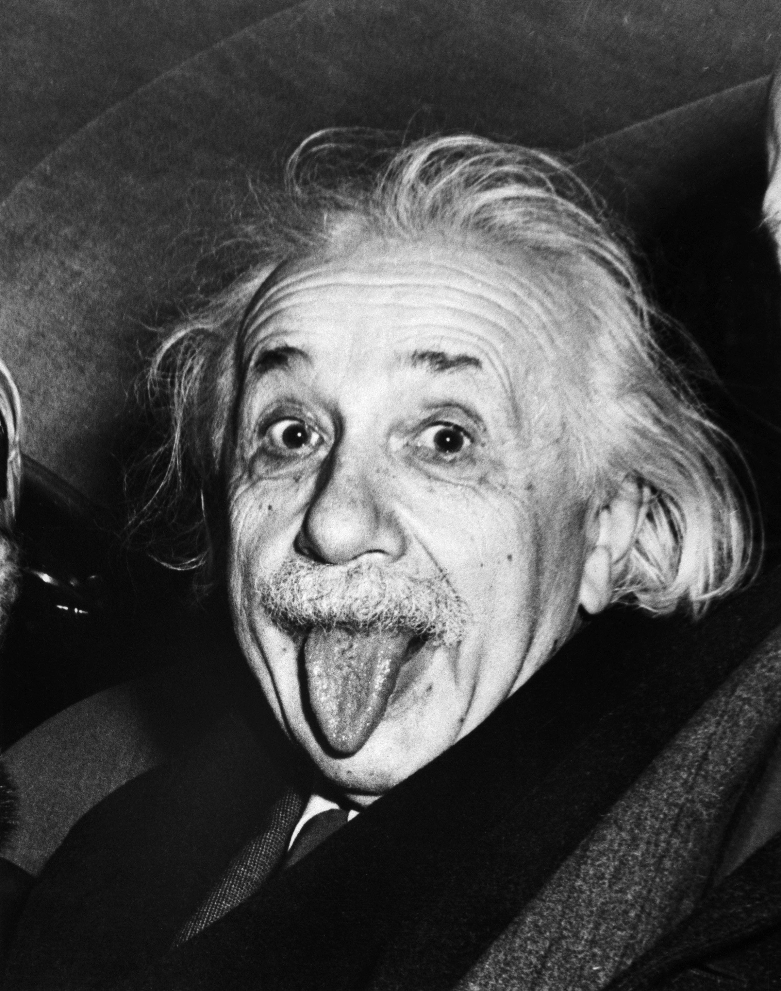 Albert Einstein (1879-1955)
* German-born theoretical physicist. He developed the general theory of relativity, one of the two pillars of modern physics (alongside quantum mechanics). Einstein's work is also known for its influence on the philosophy of science. Einstein is best known in popular culture for his mass–energy equivalence formula E = mc2 (which has been dubbed 'the world's most famous equation').

## Repeats

 Nicola Tesla (1856-1943)

* Serbian American inventor, electrical engineer, mechanical engineer, physicist, and futurist best known for his contributions to the design of the modern alternating current (AC) electricity supply system

 Thomas Edison (1847-1931)

* American inventor and businessman. He developed many devices that greatly influenced life around the world, including the phonograph, the motion picture camera, and the long-lasting, practical electric light bulb.

 Albert Einstein (1879-1955)

* German-born theoretical physicist. He developed the general theory of relativity, one of the two pillars of modern physics (alongside quantum mechanics). Einstein's work is also known for its influence on the philosophy of science. Einstein is best known in popular culture for his mass–energy equivalence formula E = mc2 (which has been dubbed 'the world's most famous equation').